PROJECT REPORT TEMPLATE

Voyage Vista : Illuminating Insights From Uber Expeditionary Analysis

1. INTRODUCTION:

* OVERVIEW: In this project, we are used to develop and try to gave an explanation about the Voyage Vista which is used to make people more easier to travel all around the world. Many uber apps are there to develop security and convenience towards the people.
* PURPOSE : The main purpose of the project is to develop security among the people while travelling and people can easily travel all over the country. Also people can visit the world with less expenses. And also it would economically benificial for people and also they don’t need any separate guide for their travel

1. PROBLEM DEFINITION & DESIGN THINKING

* EMPATHY MAP :

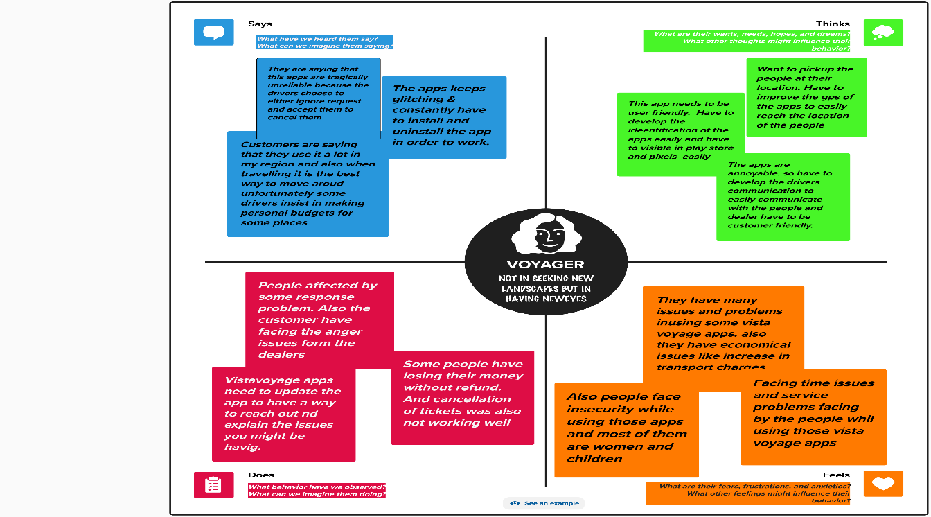

* IDEATION & BRAINSTORMING MAP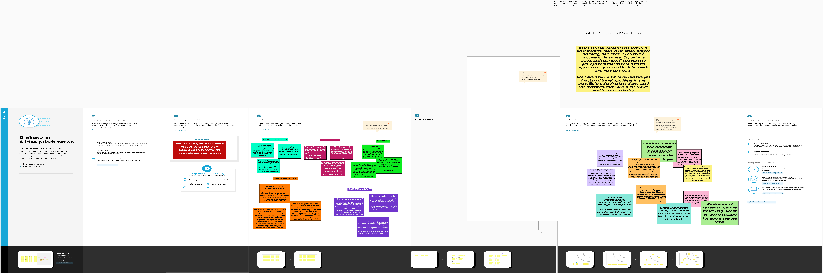

1. RESULT:

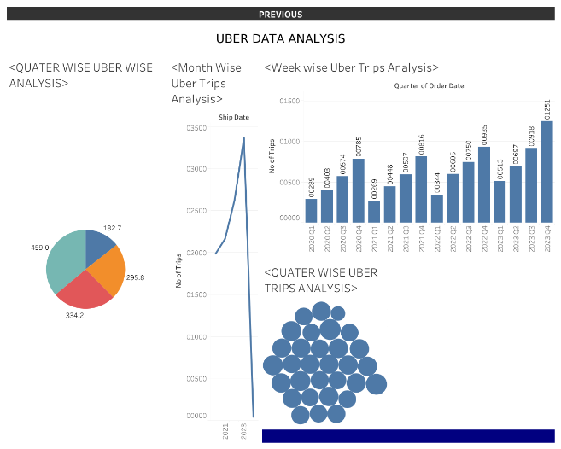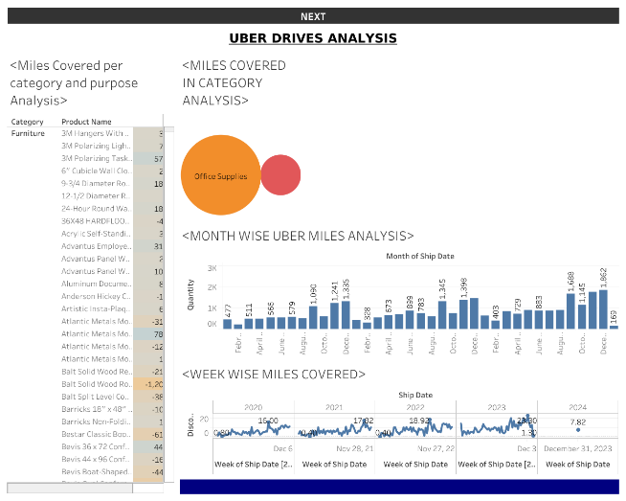

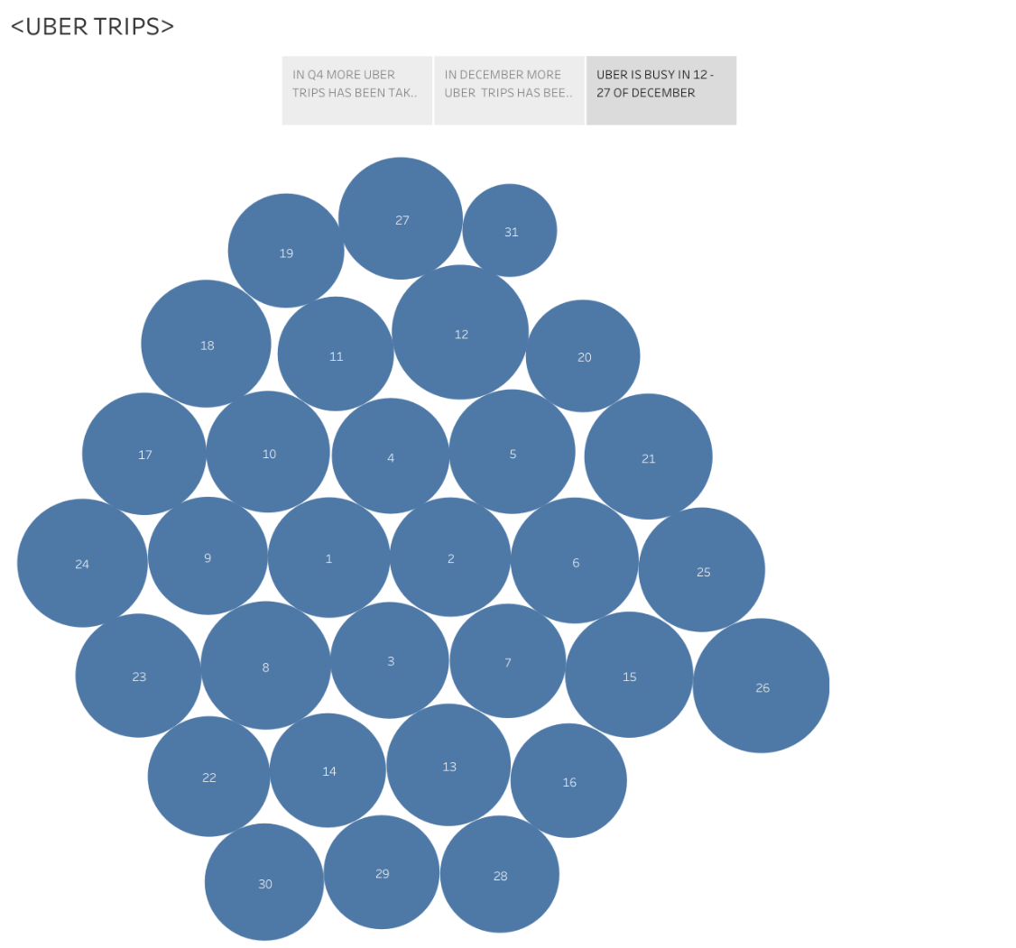

1. ADVANTAGES AND DISADVANTAGES :

* ADVANTAGES :
* Vista voyage was widely used in the traveling agency. It helps us to easily connect to the entire world while travelling.
* Its also convenient to the people to easily travel all over the world
* It gave an idea about travelling and also easily accessible to all the people in the world.
* Also it can be economically beneficial for those people who uses uber apps and also have a well knowledge about uber apps.
* DISADVANTAGES:
* The major disadvantage of using uber apps was it was not much safer for women and children.
* Sometimes it was economically higher costs than normal.
* Sometimes refund was not available in some uber apps it affect the economy of the people.

1. APPLICATION :

* We can book a rider for now or later. This is the basic feature that all apps like uber needed.
* We can track real time tracking of drivers.
* We can split the fare amount of the travel with our colleagues.
* It also have multiple payment option.
* We can also give driver review and rating to the apps for development of the apps.

1. CONCLUSION :

* From the above lines we can conclude that uber apps are user friendly and also have some disadvantages while using thise apps. But we can use those apps carefully and also we can giver reviews and rating to develop the apps and to overcome the disadvantages easily by developing the apps. Some problems can be solved by making the use of the apps widely all over the world.

1. FUTURE SCOPE :

* The main scope of the project was it can be easily accessible by the people all over the country and it should be convenient to people to access the apps.
* In future it plays a major role in everyone’s life as it would be more popular among the people.
* People can also uses this apps with full security and without lack of communication.
* It would be more popular among voyagers who uses traveling apps to make their travel much more easier.